Analysis of Ethereum Transactions and Smart Contracts Report
Table of Contents
1. PART A – TIME ANALYSIS 1
2. PART B – TOP TEN POPULAR SERVICES 1
3. PART C – TOP TEN MOST ACTIVE MINERS 1
4. PART D – DATA EXPLORATION 1

PART A – TIME ANALYSIS
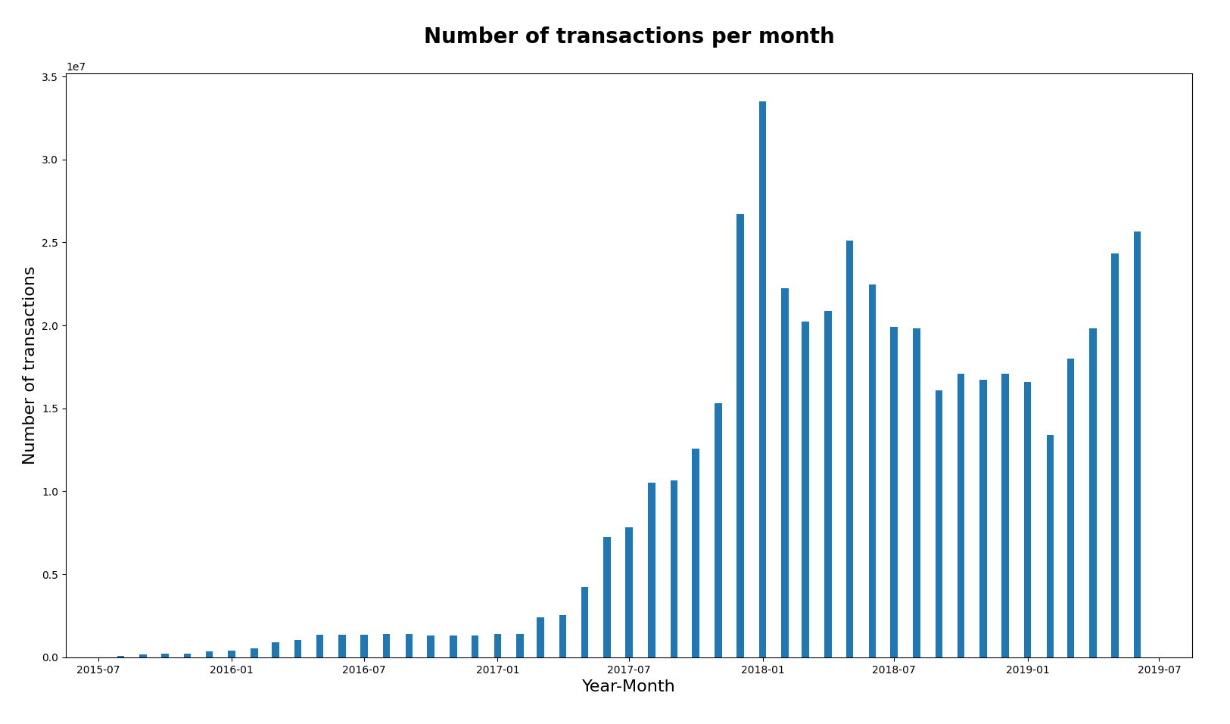
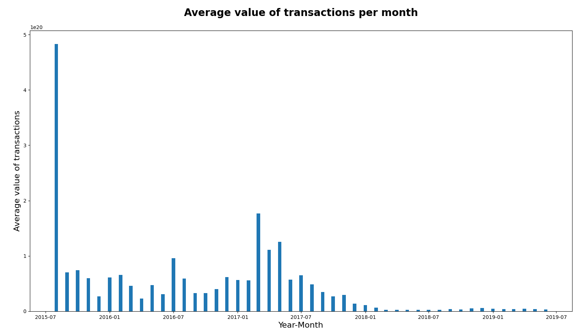

PART B – TOP TEN POPULAR SERVICES

PART C – TOP TEN MOST ACTIVE MINERS

PART D – DATA EXPLORATION

